**EDUCATION**

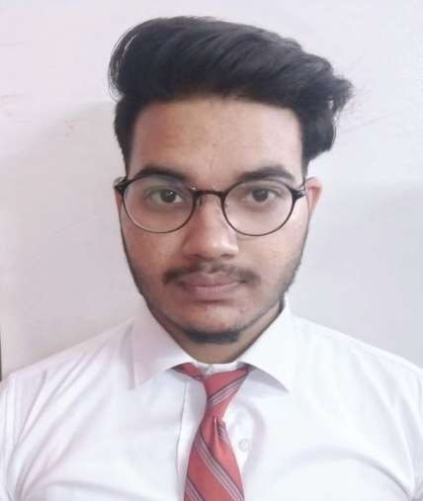

Bachelors in Computer Science Engineering | Chandigarh University, Gharuan

*Session: 2019-2023 | Score: 7.15 CGPA*

Intermediate (HP) |The Magnet public School, Hamirpur

*Session: 2018-2019 | Percentage: 85.6%*

ROHIT THAKUR



Address: Saned- Hamirpur,H.P.- 176043E-mail: [*rt2002hit@gmail.com*](mailto:rt2002hit@gmail.com)Phone: +91 9817665339

LinkedIn:**https://**[**www.linkedin.com/in/ro**](http://www.linkedin.com/in/ro)

**hit-thakur-5076281a6**

**PROFESSIONAL SUMMARY**

# A well-organized, creative and goal- oriented graduate possessing excellent communication, problem-solving and leadership skills with a flair to explore suitable avenues in Computer Science Engineering while developing advanced projects with efficiency and quality.

**TECHNICAL COMPETENCIES**

# C++ |PYTHON | SQL

  

**INTERPERSONAL SKILLS**

# Team Leadership **|** Management & Coordination **|** Decision Making

**INTERESTS & HOBBIES**

# Writing **|** Vlogging **|** Painting **|** Travelling

**|** Reading **|** Gardening.

**LANGUAGES KNOWN**

# English **|** Hindi **|** Punjabi

**PERSONAL DETAILS**

# Mother’s Name: Mrs.Veena Kumari Father’s Name: Mr.Ravinder Singh

D.O.B : 4,feb,2002

Matriculation (HP) | Sheetal model School,Hamirpur

*Session: 2016-2017 | Percentage: 78.8%*

**TRAINING & PROJECTS**

 **Movie Recommender system: MO.RE.APPLICATION:**(April 2022) Designed an application which helps to filter-out the movies on the basis of your previous content.

This appliction have the poster of movies and their name is also highlighted.Also you can search the movie with their name.

**WRITE (X) (WITH HAND RECOGNIZATION):** (May 2021)

With the helps of write (x) we can write on are computer screen by recognizing are hand gesture .

This provide following features like:We can change color blue, yelloe, red, green also can erase whole screen with one tap.

 **Voice assistance (Mark) APPLICATION:**(April 2020)

Designed an application which helps to do some basic task by recognising the voice of user work in realtime.

With the help of this application you can open web browser, wish feature, news, play-music etc.

**ACADEMIC ACHIEVEMENTS**

 SQl for data-science from coursera

 Introduction to Big -data from coursera  Certificate of Merit in Machine Learning

**CERTIFICATIONS & AWARDS**

 Database and SQL for data science with  pythonData-structure with python

**EXTRA CURRICULAR & CO-CURRICULAR ACHIEVEMENTS**

 Three stare in hacker-rank in sql.  Sports Caption of my School.